Creating Mood Using Window Light
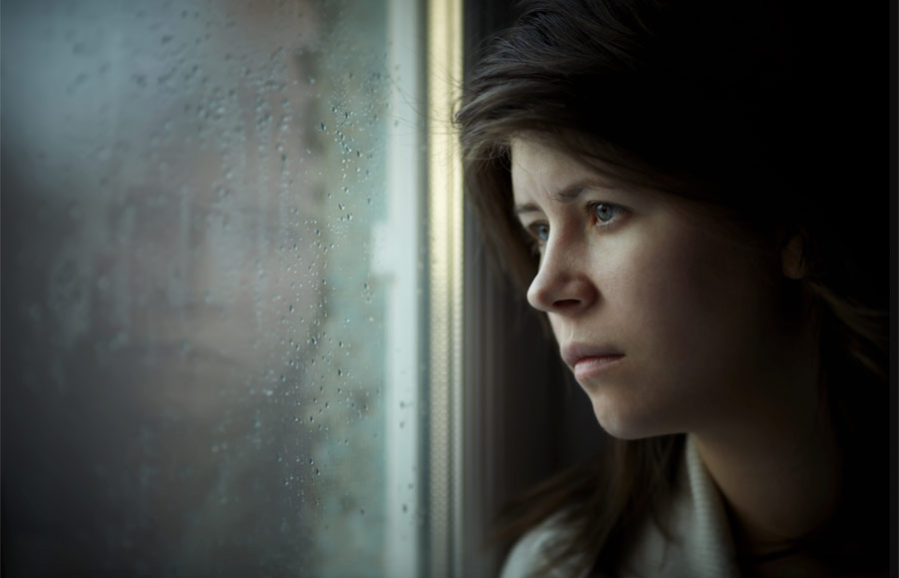
THE ASSIGNMENT
•Shoot 30 images using diffused window light to create mood.
•Pick your two favorite images & edit them -crop the photos and adjust tonal values.
•Submit your two favorites images in the Advanced Photo Google Classroom Window Light folder.
SOME TIPS ABOUT SHOOTING WINDOW LIGHT
Using diffused window light for portraits can create a beautiful mood in your photos by provide a soft side or Rembrandt light for the subject. This assignment is all about beautiful light and mood. Experiment with different locations and different poses. But window light can also create difficulties when metering, especially if the background is dark. Often when shooting window light, your camera may meter the entire scene, including the dark areas in the background. When this occurs, there is a tendency to overexpose your subject’s “lit” side. You’ll want to make sure that you correctly expose the lighter side of your subject’s face, even if it results in the other side of the subject’s face and the background area becoming dark. This is an excellent time for using manual exposure mode, or if you are using AV setting on your camera, use the exposure compensation button to refine your exposure.
SOME TIPS ABOUT SHOOTING WINDOW LIGHT
Using diffused window light for portraits can provide a soft light for the subject, but it can also create difficulties when metering, especially if the background is dark. Often when shooting window light, your camera may meter the entire scene, including the dark areas in the background. When this occurs, there is a tendency to overexpose some areas on your subject’s “lit” side. See the example below…
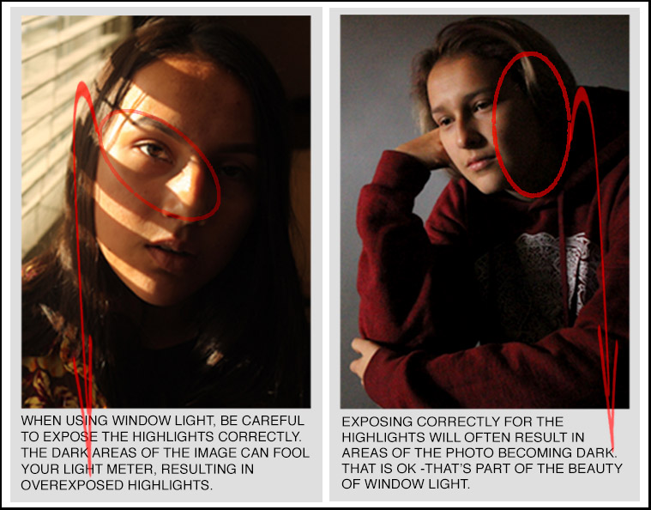
You’ll want to make sure that you correctly expose the lit side of your subject’s face, even if it results in the other side of the subject’s face and the background area becoming dark. Also, be aware that when you shoot in window light, you may need to adjust the camera’s white balance. The diffused light coming through the window can add a blue or greenish hue to your images. Look critically at the color temperature of your first exposure. You may need to use the “shade” setting to correct the blue cast in your image. Another option is to convert your image into black and white for a more “timeless” window light “look”.

