Creating Mood Using Window Light
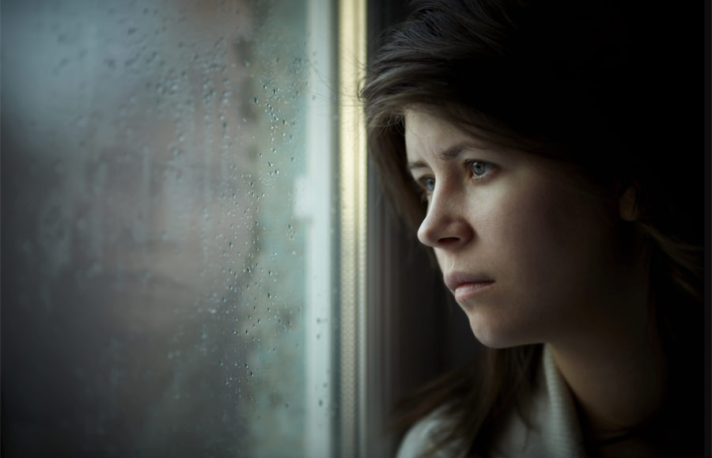
THE ASSIGNMENT
•Shoot 30 images using window light to create mood.
•Pick your two favorite images, edit them (crop and adjust tonal values).
•Do a screen shot of your thirty images. Write your name and "Window Light" on the proofsheet.
•Submit your two favorites and the proofsheet in the GOOGLE CLASSROOM server.
•Save your images as:
p3advlastname_window1
p3advlastname_window2
p3advlastname_window3
(the third image will be a screengrab of your proof sheet).
•PUT THE 2 PORTRAIT IMAGES ON A BACKGROUND!
•THE PROOFSHEET DOES NOT NEED TO BE ON A BACKGROUND.
SOME TIPS ABOUT SHOOTING WINDOW LIGHT
Using diffused window light for portraits can provide a soft light for the subject, but it can also create difficulties when metering, especially if the background is dark. Often when shooting window light, your camera may meter the entire scene, including the dark areas in the background. When this occurs, there is a tendency to overexpose some areas on your subject’s “lit” side. See the example below…
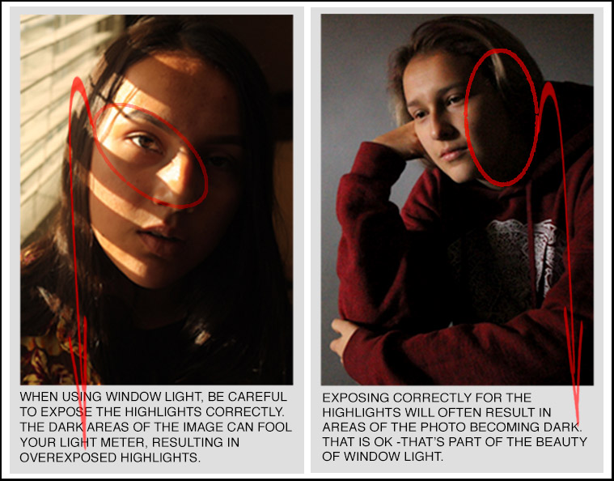
You’ll want to make sure that you correctly expose the lit side of your subject’s face, even if it results in the other side of the subject’s face and the background area becoming dark. Also, be aware that when you shoot in window light, you may need to adjust the camera’s white balance. The diffused light coming through the window can add a blue or greenish hue to your images. Look critically at the color temperature of your first exposure. You may need to use the “shade” setting to correct the blue cast in your image. Another option is to convert your image into black and white for a more “timeless” window light “look”.

