MARY ELLEN MARK

This is an excerpt from the New York Times obit about Marry Ellen Mark, who died in 2015. The links will take you to various articles and videos about this renowned photographer.  
  
Ms. Mark began her career with magazines like Look and Life, taking a [classic documentary approach](https://www.youtube.com/watch?v=ByVoCwqvnLI) to often difficult material and usually working in black and white. Early on, she showed a remarkable ability to win the confidence of her subjects, and she maintained contact with many of them through the years.

Her latest book, “Tiny: Streetwise Revisited,” for example, returns to the main character in the book “Streetwise,” one of several homeless Seattle youths she photographed in the early 1980s. The book is set to be published by Aperture in the

In the 1990s, Ms. Mark made the transition to fashion photography and portraiture, with ad campaigns for clients like Coach, Eileen Fisher and Heineken. At the same time she continued her [documentary work](http://www.newyorker.com/culture/photo-booth/video-mary-ellen-mark-on-street-photography), photographing high school proms, autistic children and families in homeless shelters.

“She was a great storyteller,” said Melissa Harris, the editor in chief of the Aperture Foundation, who edited several of Ms. Mark’s books. “She got to know the subjects she photographed very well, and she was able to convey who they were and how they lived, as well as a sense of their interior lives. There are not that many photographers who can do that.”

Mary Ellen Mark was born on March 20, 1940, in Philadelphia, and grew up nearby in Elkins Park. She had two main ambitions in high school, she [told The New York Times Magazine](http://www.nytimes.com/1987/07/12/magazine/the-unflinching-eye-photojournalist-mary-ellen-mark.html?pagewanted=all) in 1987: to become the head cheerleader and to be popular with boys. She succeeded at both.  
  
She studied at the University of Pennsylvania, where she earned a bachelor’s degree in painting and art history in 1962 and a master’s degree in photojournalism in 1964. She was particularly interested in the work of documentarians like Henri Cartier-Bresson, Robert Frank and Dorothea Lange.

“I remember the first time I went out on the street to shoot pictures,” she told the magazine Communication Arts in 1997. “I was in downtown Philadelphia and I just took a walk and started making contact with people and photographing them, and I thought: ‘I love this. This is what I want to do forever.’ There was never another question.”

After college, Ms. Mark traveled to Turkey on a Fulbright scholarship, an experience that provided some of the subject matter for her first book, “Passport,” published in 1974.

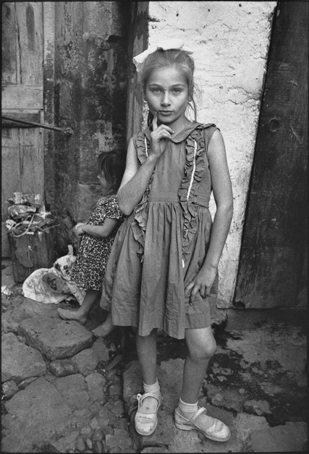

Beautiful Emine posing, Trabzon, Turkey, 1965. Credit:Mary Ellen Mark

After she moved to New York in the late 1960s, Look magazine assigned her to photograph Federico Fellini on the set of “Satyricon” in Rome, and also heroin addicts at a London clinic. She went on to work for Life, Time, Rolling Stone, The New York Times Magazine and other publications.

She studied at the University of Pennsylvania, where she earned a bachelor’s degree in painting and art history in 1962 and a master’s degree in photojournalism in 1964. She was particularly interested in the work of documentarians like Henri Cartier-Bresson, Robert Frank and Dorothea Lange.

“I remember the first time I went out on the street to shoot pictures,” she told the magazine Communication Arts in 1997. “I was in downtown Philadelphia and I just took a walk and started making contact with people and photographing them, and I thought: ‘I love this. This is what I want to do forever.’ There was never another question.”

After college, Ms. Mark traveled to Turkey on a Fulbright scholarship, an experience that provided some of the subject matter for her first book, “Passport,” published in 1974.

After she moved to New York in the late 1960s, Look magazine assigned her to photograph Federico Fellini on the set of “Satyricon” in Rome, and also heroin addicts at a London clinic. She went on to work for Life, Time, Rolling Stone, The New York Times Magazine and other publications.

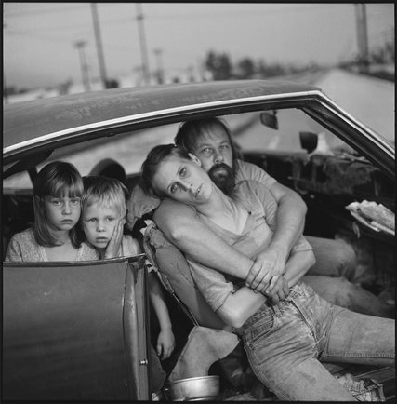

A photograph by Ms. Mark of the Damm family in Los Angeles in 1987.   
 She used a classic documentary approach, usually working in black and white. Credit: Mary Ellen Mark

In 1978, Castelli Graphics in Manhattan presented “Ward 81,” an exhibition of photographs Ms. Mark had taken at the maximum-security women’s ward of a state mental hospital in Oregon, where she lived for two months. The rapport she developed with the inmates translated into strikingly de-dramatized representations of humans in extreme circumstances, in contrast to the freakish portraits made by Diane Arbus.

The empathy and humanism of the work, published in book form in 1979, impressed critics. Robert Hughes, in Time, called “Ward 81” “one of the most delicately shaded studies of vulnerability ever set on film.” After the show, Ms. Mark signed with the Magnum photo agency.

Her interest in social outcasts remained a constant throughout her career, reflected in the book “Falkland Road: Prostitutes of Bombay” (1981), unusual for being in color. While on assignment for Life in 1983, she began photographing homeless teenagers in Seattle, a ragtag collection of small-time drug dealers, prostitutes and panhandlers who populate the pages of “Streetwise,” published in 1988. With her husband, the filmmaker Martin Bell, who survives her, she turned her encounters into a film, which was nominated for the Academy Award for best documentary in 1984.

Her other books include “Indian Circus” (1993), “Twins” (2003), “Prom” (2012) and “Man and Beast” (2014), as well as several collections that gather her best work, notably “Mary Ellen Mark: Portraits” (1995), “Mary Ellen Mark: American Odyssey” (1999) and “Exposure” (2006). She was the subject of a traveling retrospective exhibition, “Mary Ellen Mark: 25 Years,” which opened in 1992 at the International Center of Photography in Manhattan.

In 2014, she was given the Lifetime Achievement in Photography Award from George Eastman House.

“I would die if I had to be confined,” Ms. Mark told an interviewer for the introduction to “Passport.” “I don’t want to feel that I’m missing out on experiencing as much as I can. For me, experiencing is knowing people all over the world and being able to photograph.”